# **To install docker download docker interface:**

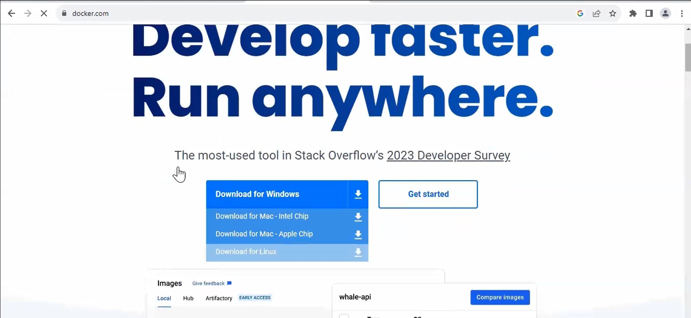

And follow instructions in this link :

<https://github.com/Gamal-Mohammad/instructions/blob/main/docker-setup-on-ubuntu>

Login to your Ubuntu machine & then run the following commands

sudo apt update

sudo apt install curl (هننزل بيه ال docker jpg key )

sudo curl -fsSL https://download.docker.com/linux/ubuntu/gpg | sudo gpg --dearmor -o /etc/apt/trusted.gpg.d/docker.gpg

sudo add-apt-repository "deb [arch=$(dpkg --print-architecture)] https://download.docker.com/linux/ubuntu $(lsb_release -cs) stable"

sudo apt update

sudo apt -y install lsb-release gnupg apt-transport-https ca-certificates curl software-properties-common

sudo apt -y install docker-ce docker-ce-cli containerd.io docker-compose-plugin docker-registry

sudo usermod -aG docker $USER

newgrp docker

docker compose version

systemctl status docker.service

docker pull httpd

# **docker images and containers**

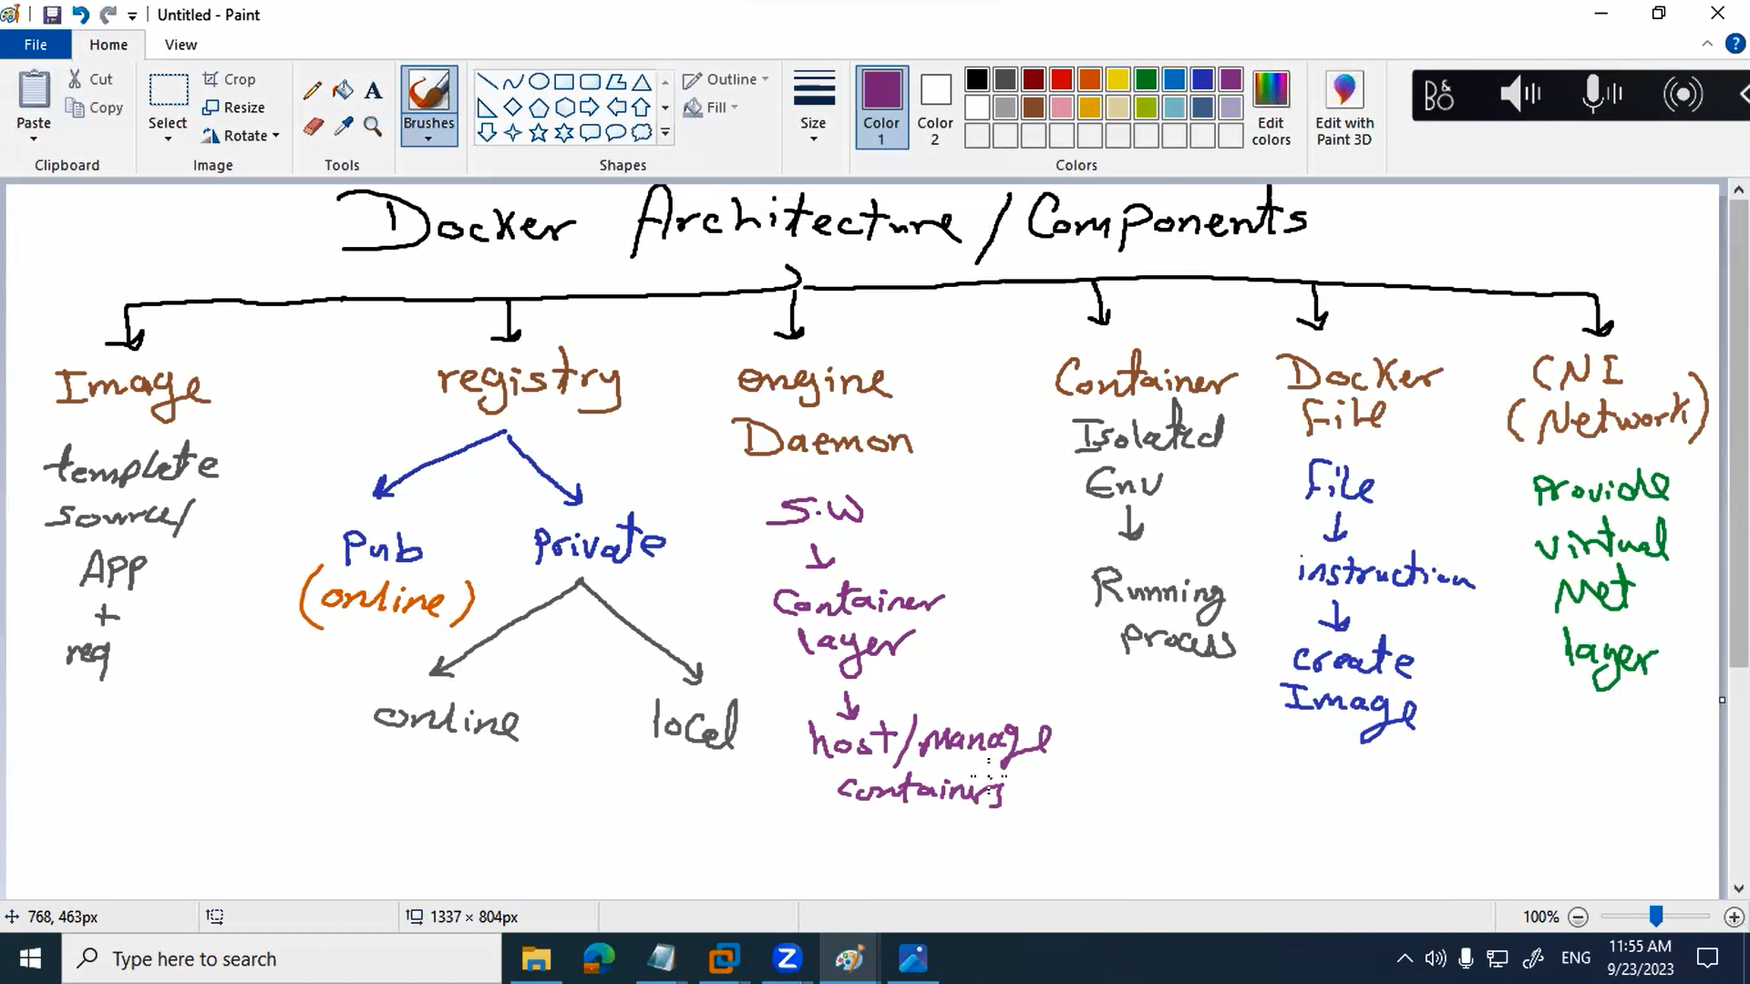

*Engines* *(SW that host and manage the containers)* create the *container* from docker *image* *(last stable state from my app)*which stored in *registry(docker hub)* using the *docker file(file contains the instructions to create the image)* and these containers can communicate with each other using the *CNI* container network interface(object that provide virtual network).

* We can containerize our app or create an empty container and setup my app with all it’s dependencies.
* **Alpine** is the base image that we can create an empty container.
* Docker hub is the public registry contains docker images we can push and pull already existing images

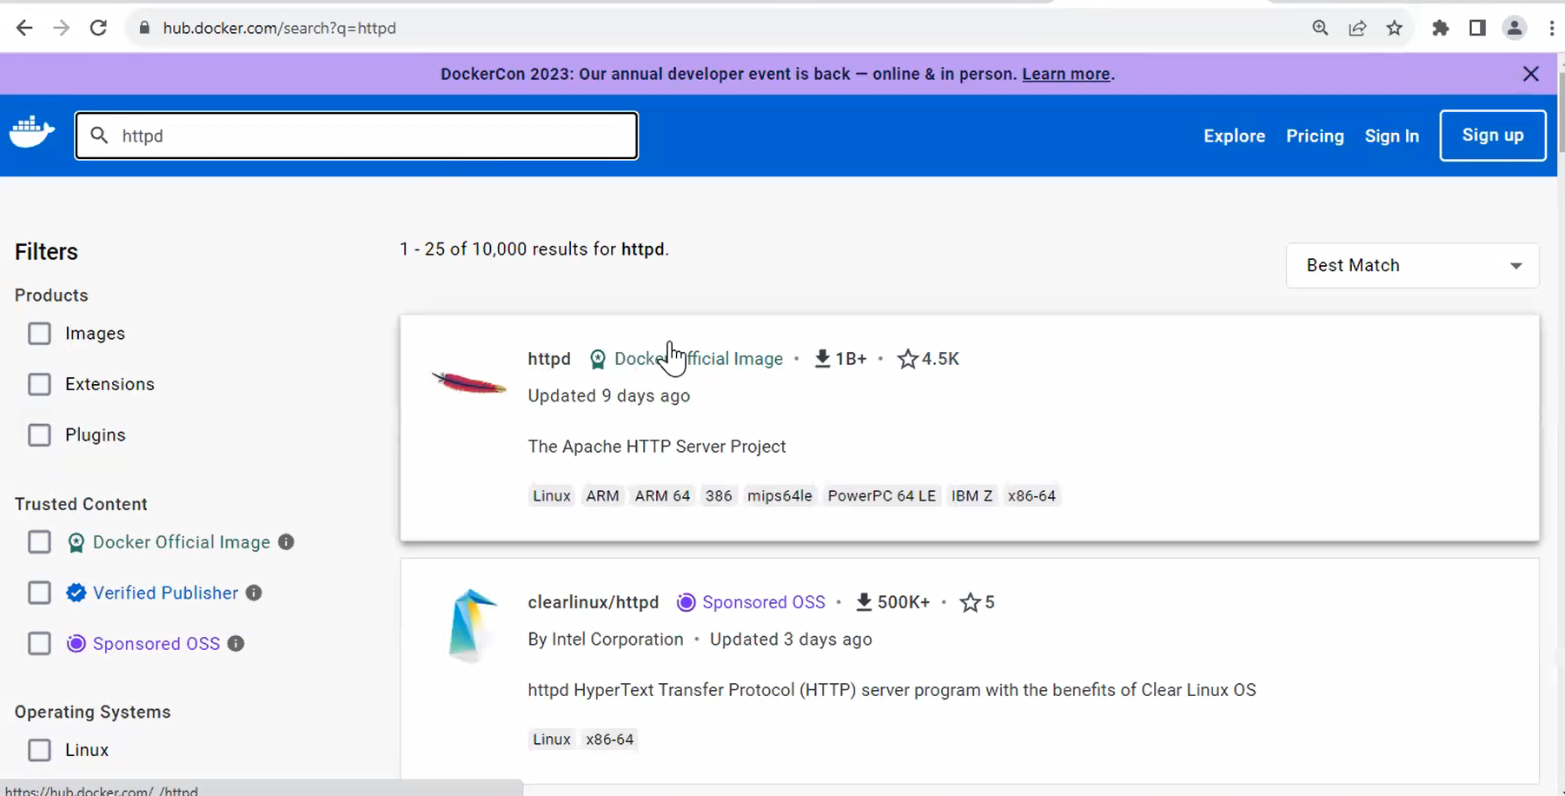

We can pull specific image with specific tag and create container from this image

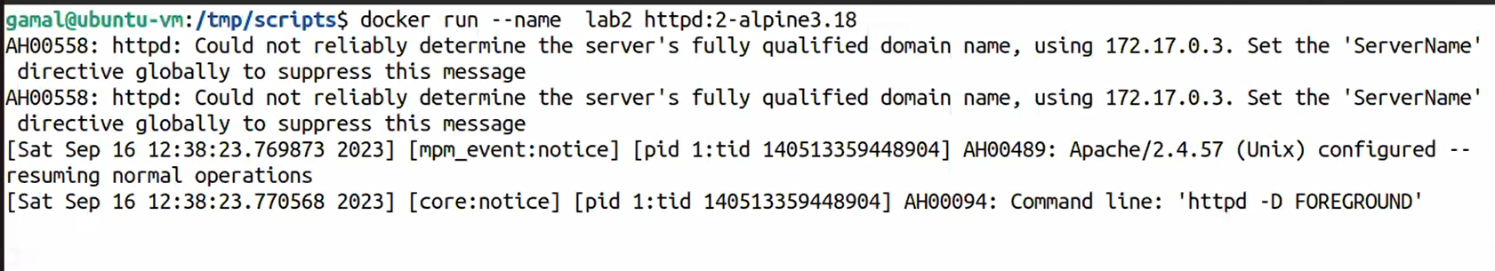

Note: **delete container** docker rm

We can’t delete running container even add -f to force delete but its not recommended or stop the container first

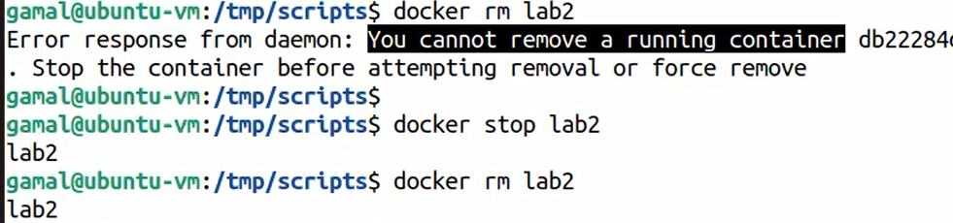

Note: **delete image**  docker rmi

We can’t delete running image has running container even this container running or not.. first we need to delete all related containers and then we can delete the img

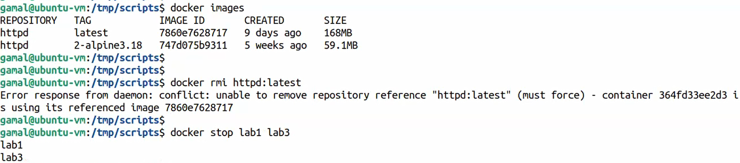

Commands:

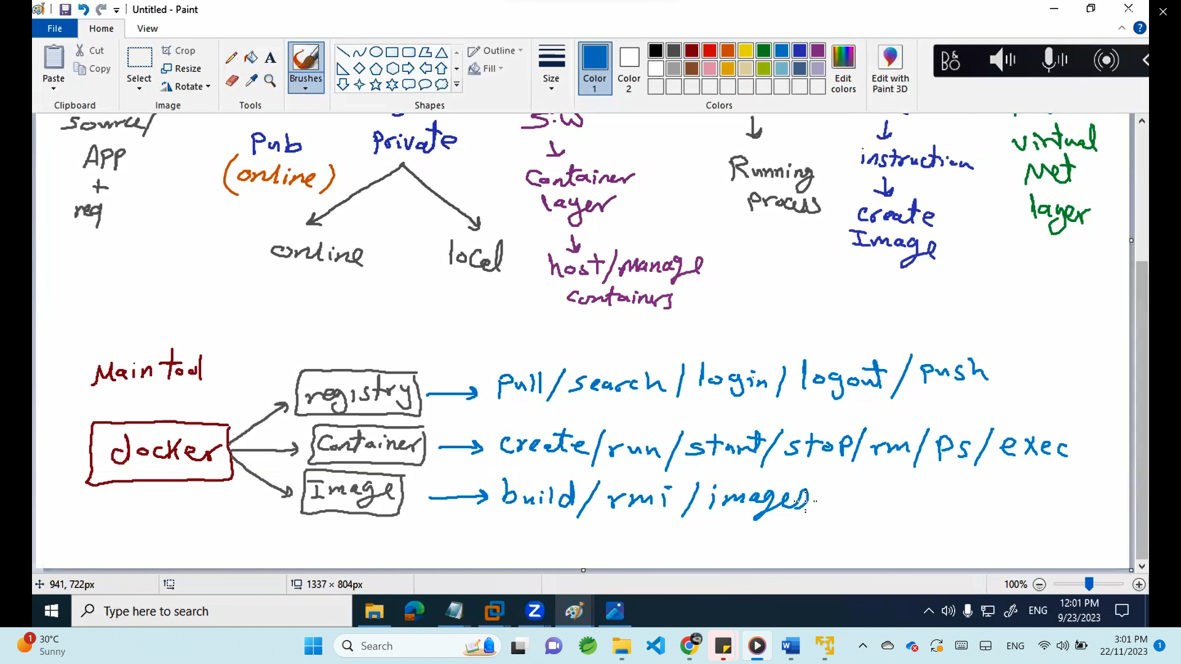

|  |  |
| --- | --- |
| Command | Explain |
| Docker | Get all docker commands |
| Docker images | List all docker images |
| Docker pull alpine | Download alpine docker image from the internet |
| Docker rmi alpine:latest | Remove image (tag required) |
| Docker search alpine , Docker search apache | Search for any image |
| Docker login , docker logout | Login /logout to your registry |
| Docker login quay.io | Login to quay.io registry |
| Docker ps | List running containers |
| Docker ps -a | List all containers even they are not running |
| Docker create –name=lab1 -p 8081:80 httpd:latest | Create container in port 8080 from image httpd |
| Docker start lab1 | Start already existing container |
| Docker rm lab3 | Delete stopped container |
| Docker exec -ti lab1 ls /etc بدخل انفذ حاجه جوه الكونتينر | Exec -i interactive and u to generate tty |
| Docker exec -ti lab1 cat /etc/os-realease | cat /etc/os-realease in lab1 |
| Docker exec -ti lab1 cat /etc/os-realease --color | --color if I want to color the output of the command |
| Docker exec -ti lab1 apt update |  |
| Docker exec -ti lab1 apt install vim |  |
| Docker exec -ti lab1 bash or sh | Login into the container (terminal changed to root@id) |
| Exit | Exit of I logged in any container and I want to exit |
| Double tab | If we are logged into any container and we want to see all commands can be run |

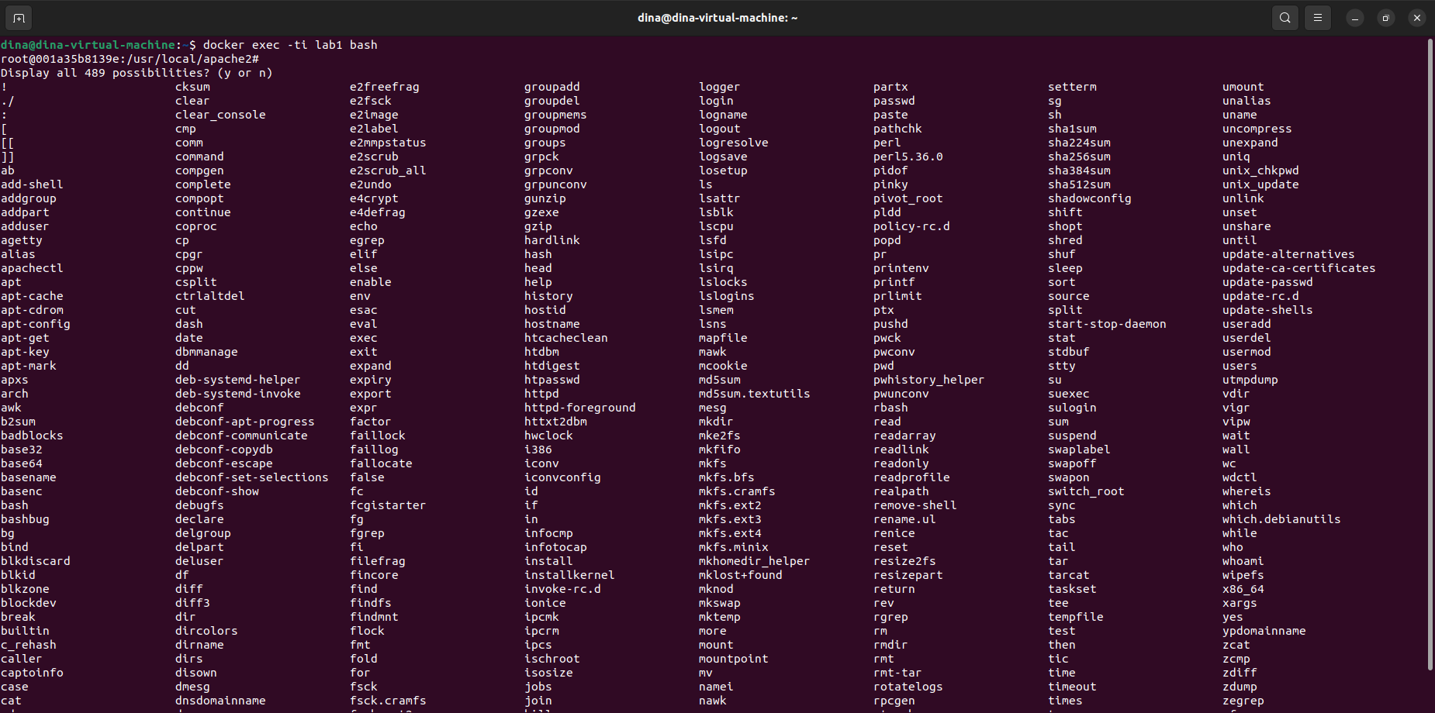

To install any pkg in the container

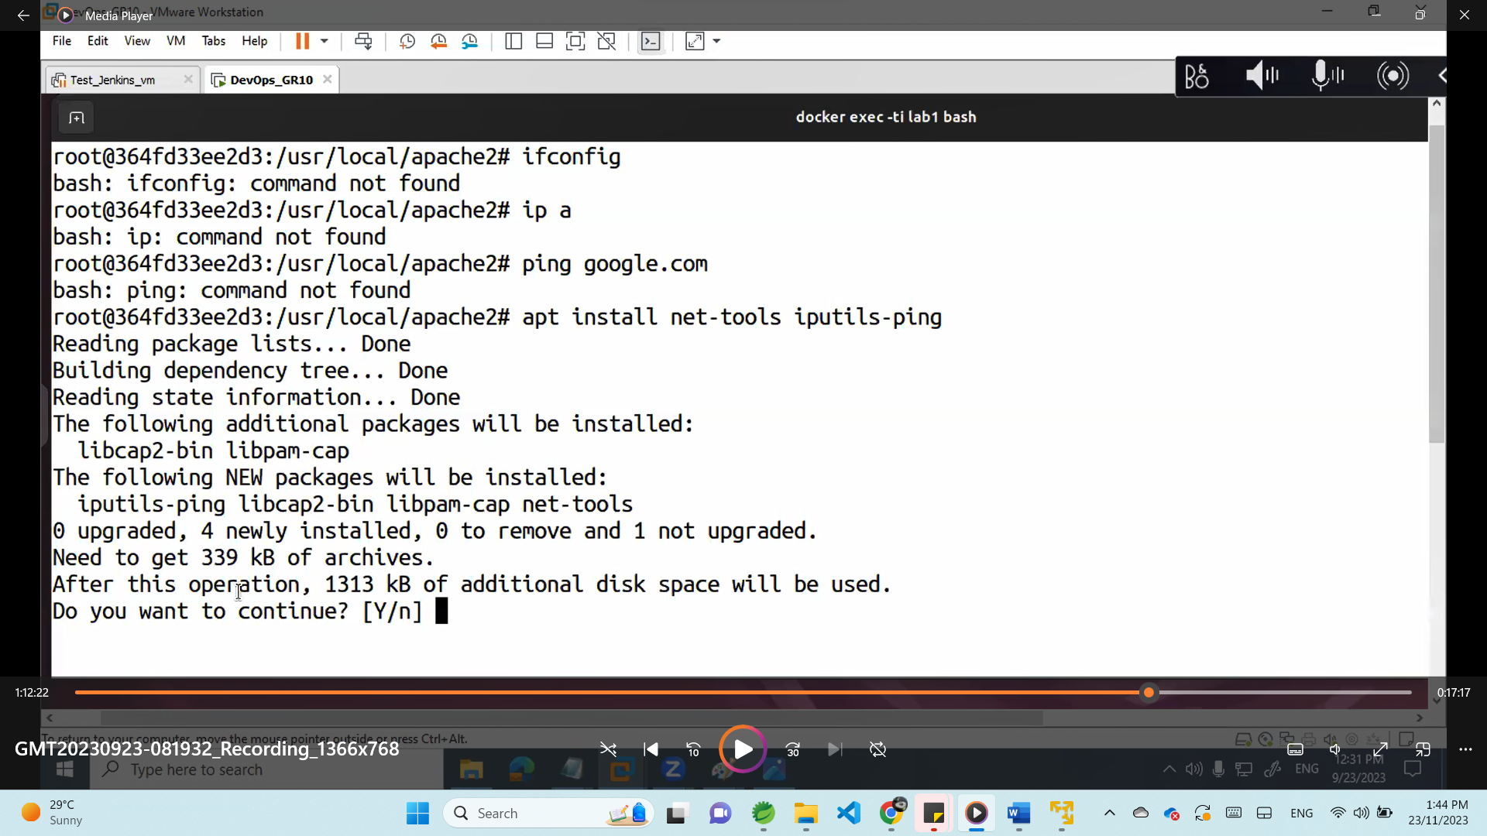

After install

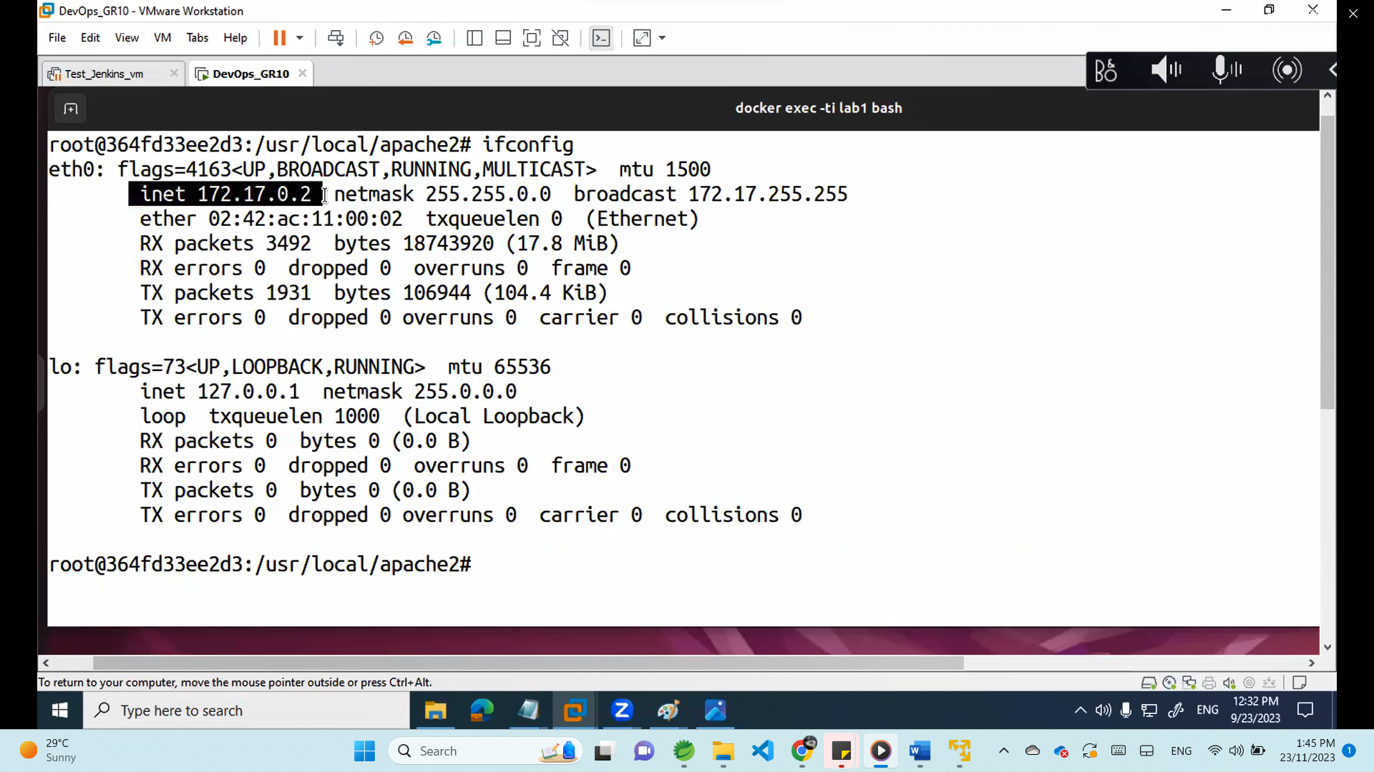

After finish all your work inside the container (exit)

Include static host name for the container.

Docker run command is a combination of creating and start as it creates a new container and starts it immediately.

docker run -d --name lab3 --hostname ***lab3*** -p 8082:80 httpd:latest

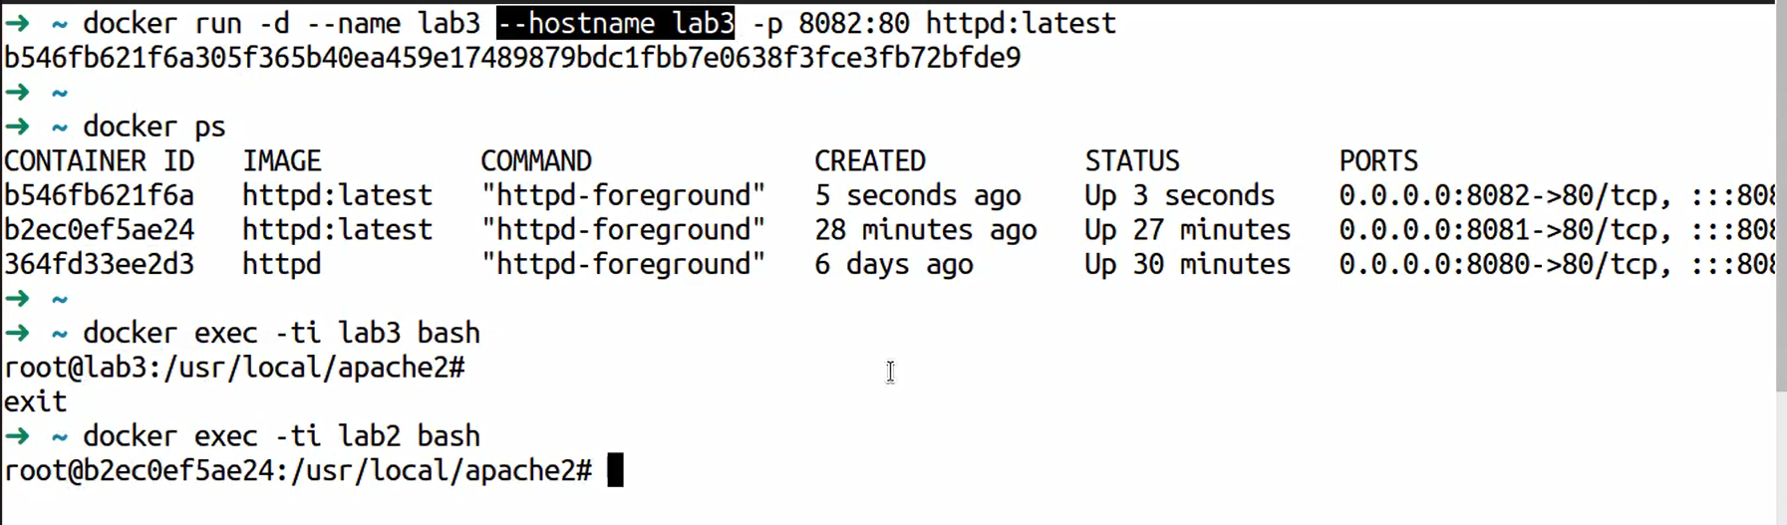

Docker run –help

And you ll find –**memory** –**CPUS** --**volumes** so we can reserve resources for the container

-Restart docker ll terminate all running containers :

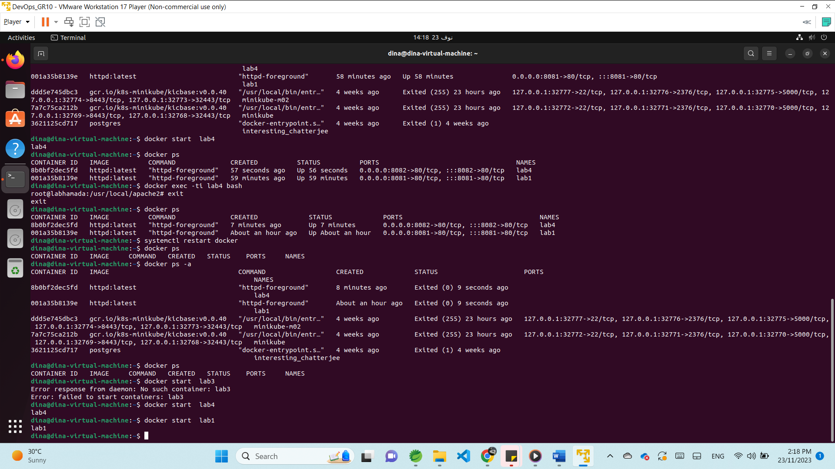

-If I want to make the containers start automatically **–restart always** when we create the container

docker run -d --name lab5 --hostname lab5-p 8083:80 **--restart always** httpd:latest

# **Docker Network - CNI(container network interface)**

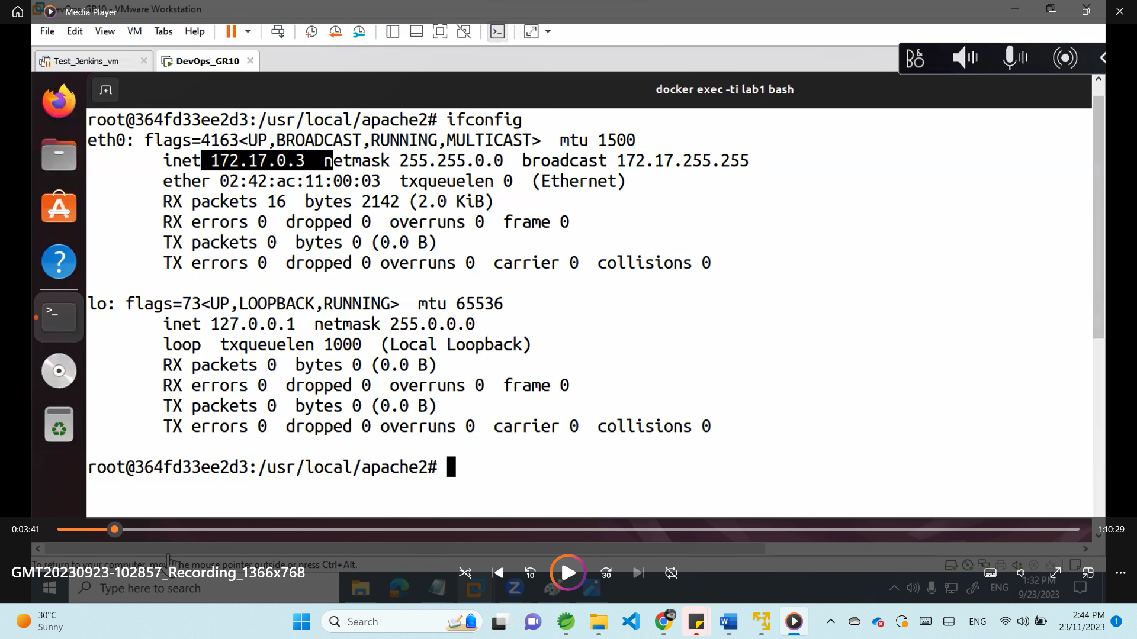

The container is virtual isolated environment , if I ping to it’s ip it ll not respond

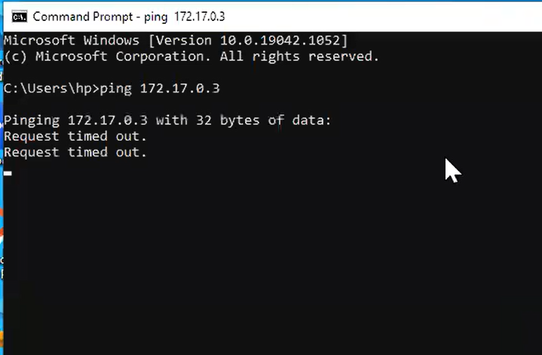

So if I want to access this containers it should be mapped (exposed) to the physical NIC using virtual networking (CNI) to do this we need to:

- create vsw(virtual switch)

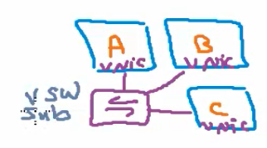

-Connect the containers to this virtual switch (till this step containers can communicate with each other but they are still not accessable to the user)

-map this virtual switch to the physical NIC using CNI bridge driver (now the containers can access the internet but still not accessible to the user )

-port mapping between the physical NIC port and the container port ,so the NIC can forward the user request to the container port (containers now accessible )

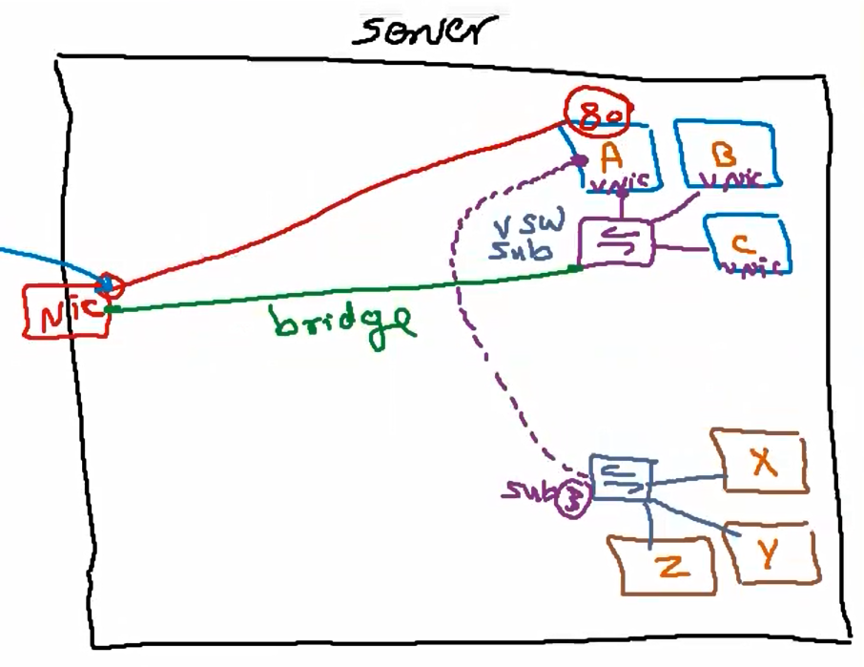

1. The containers needs to communicate 🡪 all should be in the same network (virtual switch)
2. The container can req any thing from the internet 🡪 they should be assigned to bridge

(mapping between NIC and the virtual network by CNI container network interface using bridge )

1. The containers need to be accessible for any external request 🡪port mapping
2. Container A need to access X 🡪 connect X virtual switch with A virtual NIC

CNI driver (virtual network)types:

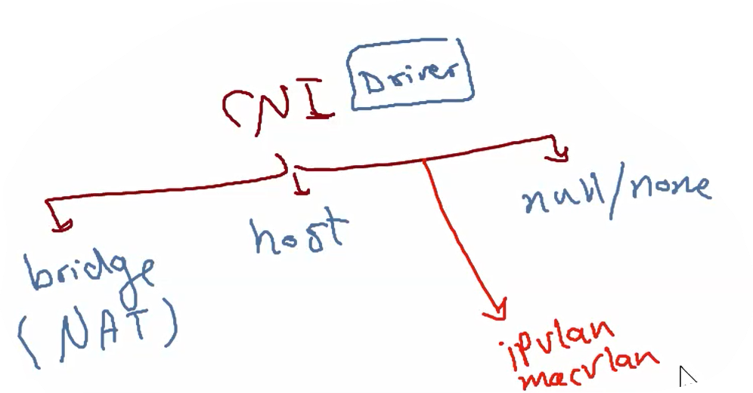  
**bridge**: all connected containers can access the internet and all can be accessed but needs port map

**Host**: host machine only can access the contains and the containers can’t connect to internet

**Null/none**: container can’t access any other containers or internet and can’t be accessed

**Ipvlan/macvlan**: used when I want the container access the internet directly

Network commands:

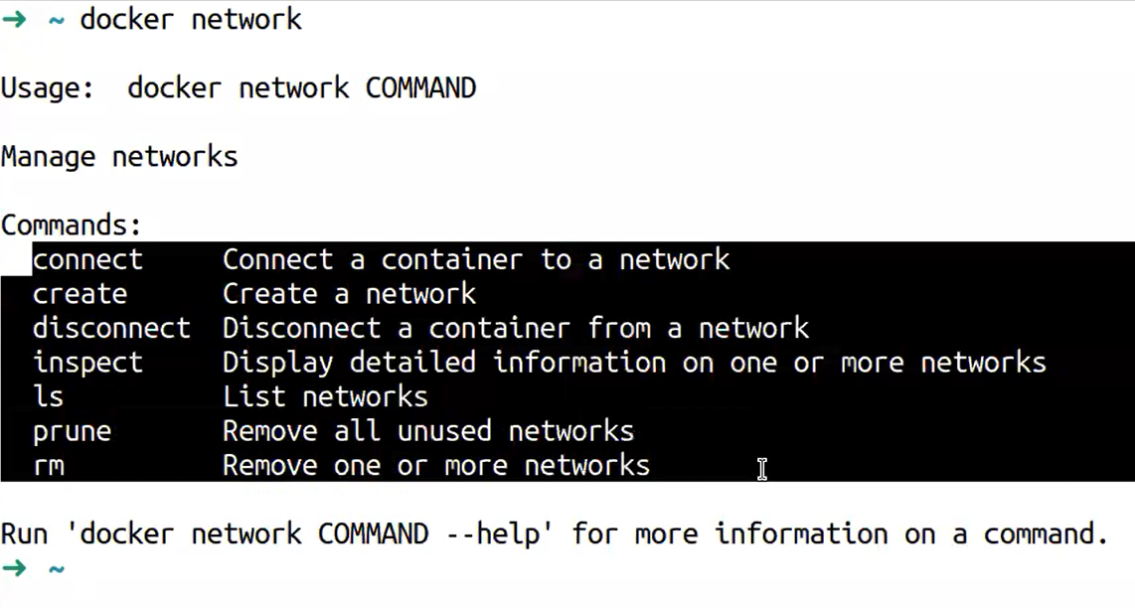

|  |  |
| --- | --- |
| Docker network ls | List all networks |
| Docker network inspect bridge | Get bridge network details |
| Docker network create senior | Create new network called senior |
| Docker network create –help | Get all available options in network create  Ex: ) subnet ,internal,driver, gateway,ip range. |
|  |  |
|  |  |
|  |  |
|  |  |

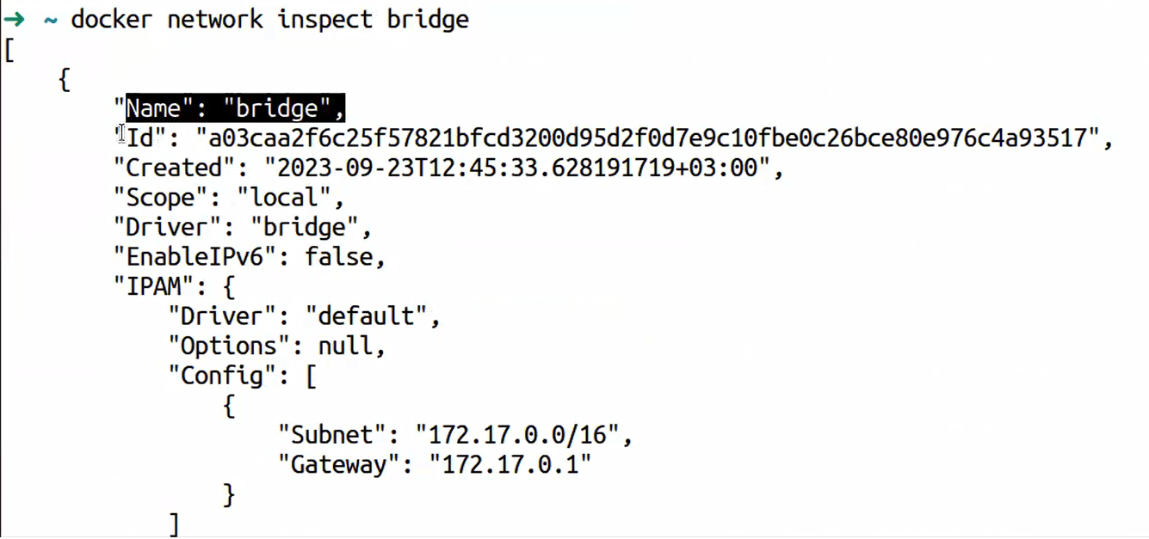

Inspect display the network details like :

-subnet and gateway

-internal if false means this network can access the internet

-containers: containers that connected to this network

**Any new container once created is assigned to bridge network by default.**

1-Create two network one internal and one able to access the internet:

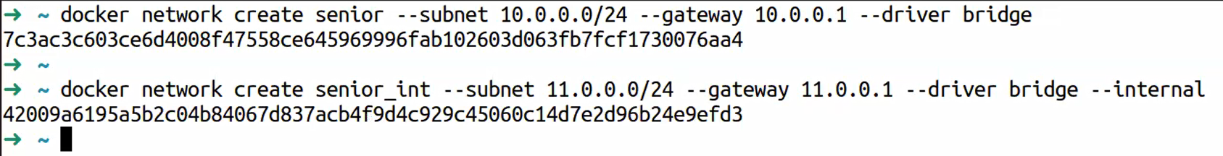

2- create container assigned to network senior and container assigned to senior_int



**We ll find the container in caontainers section if we inspect network senior**

**And we can open HostIp:7070 we can call hostIp:7070 it ll respond**

# **Docker file**

We create file to generate image that is not exist before so we need to add our dependencies

1. My application source
2. All requirements
3. Dpends on which OS

1- search for base OS pure image 🡪 docker search rhel or docker search ubi (universal base img) ,docker search ubuntu , docker search centos …

2-pull this image

3-add to instructions [From : image] ,and add all my instructions

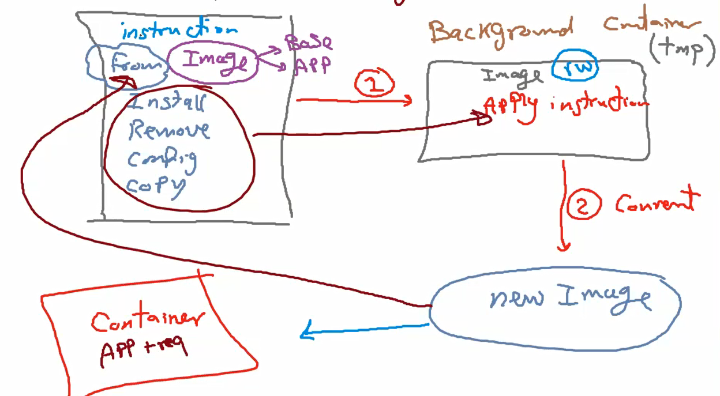

How to create an image from(dockerize) my app :

1. Get base OS img (ubi) or app img(ex:apache ,nginx) (read only image)🡪 from
2. Add all instructions , requirements,configurations in the docker file
3. Implicitly docker create temp container and run all docker file instructions on it
4. Then docker convert this container to new image (read only) –>(app dockerized)

Instructions could be :

Run vs cmd

Run commands ll be executed in temp(background) container and the result of this cmd ll be exists in the new img

Cmd command ll be executed when we create new container from the new created img (startup script)

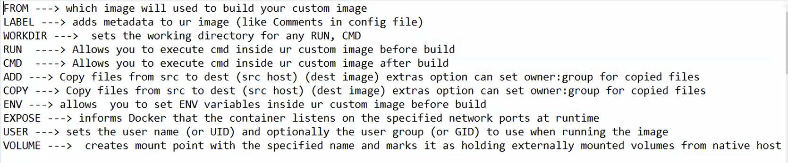

Expose: البرنامج بتاعى محتاج البورت ده عشان يستخدمها افتحلى البورت مثلا 80 هحتاجه

User : لو انا عايز اعمل يوزر عشان هستخدمه بعد كده

Volume : لو عايز اعمل مكان بره يقدر الكونتينر يستخدمه بره الكونتينر

Env : environmental variables بتاعه أي حاجه بنزلها زي الجافا

## EX:1 create new image from running container : in cmd : #docker (بتجيب كل الأوامر الى اقدر استخدمها )

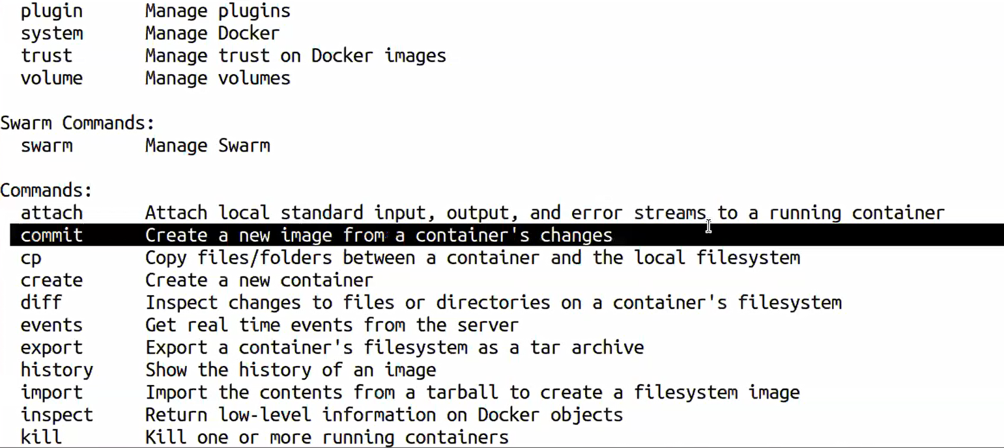

Imageبناخد سكرين شوت من الكونتينر الى شغال و نحطها ف

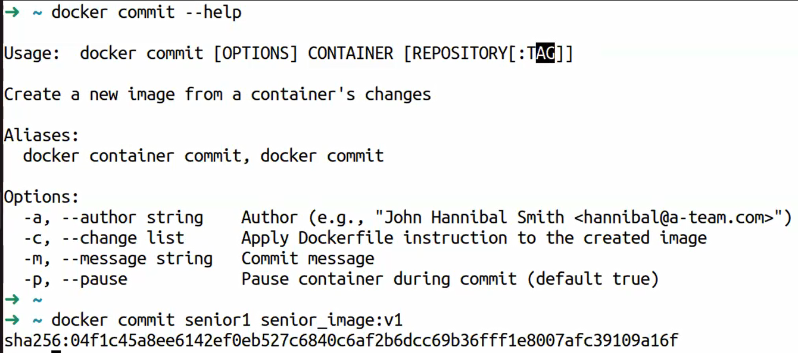

Senior 1 من الكونتينر الى اسمه Img انا كده عملت

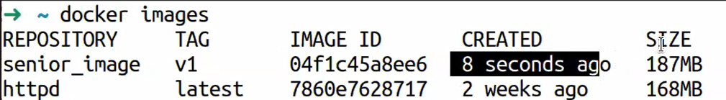

Ex:2 create new image from scratch:

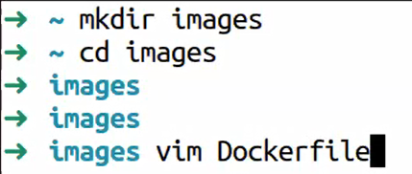لازم يكون اسم الفايل كده

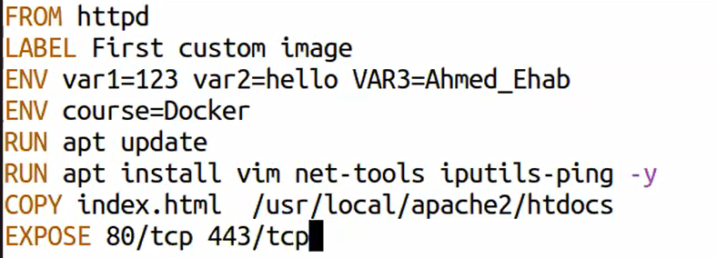

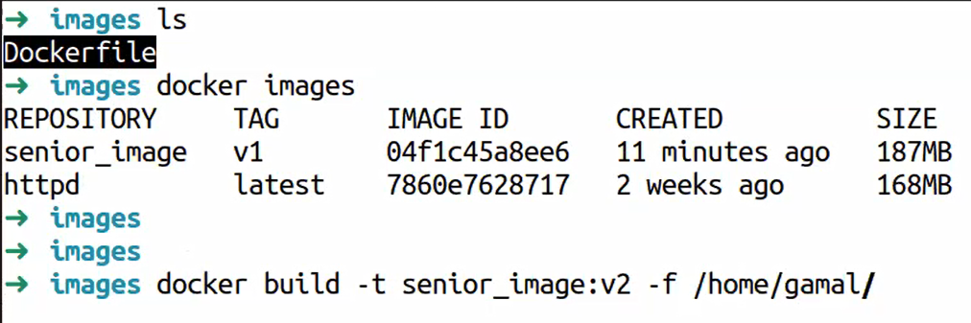

/home/gamal is the location of the Dockerfile if im already in the same location add ( .)



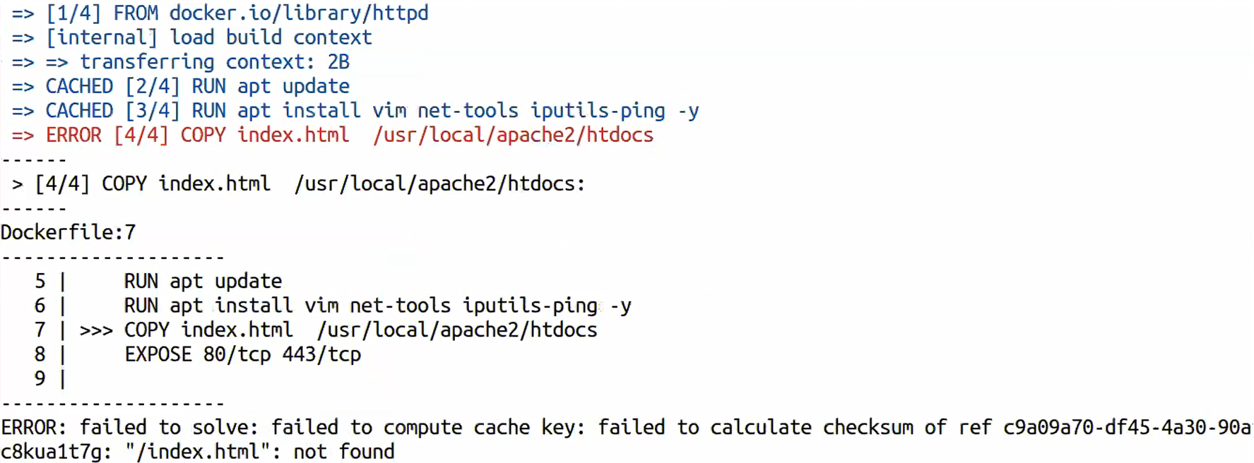file index don’t exist

In this case when we fix the issue and add the file index , the passed steps ll not run again , it ll start from step 5



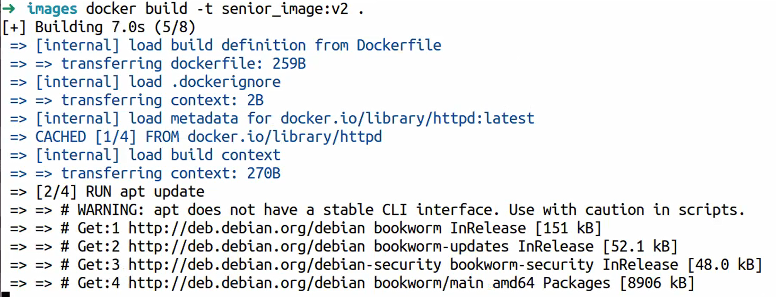

Done:

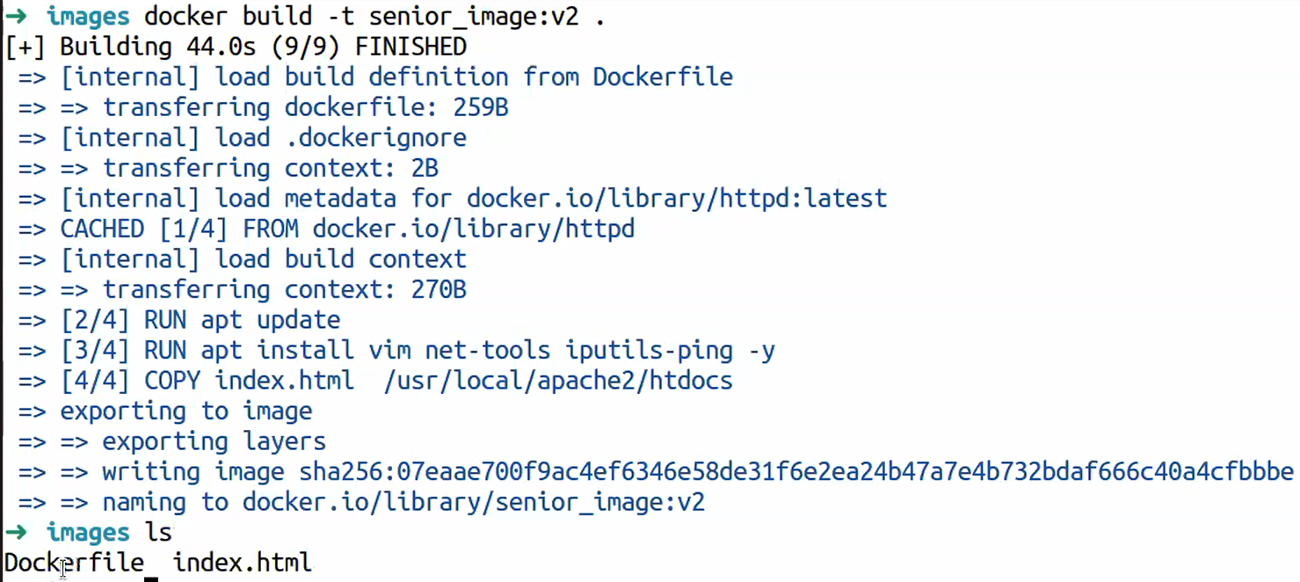

Senior_image v2 created :

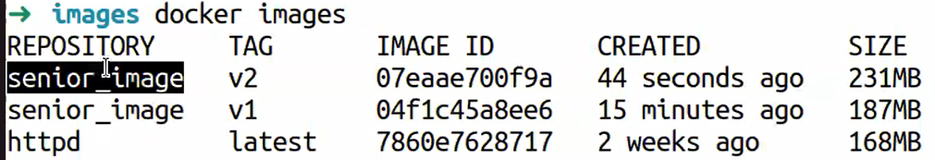

Now i can create container from the new image

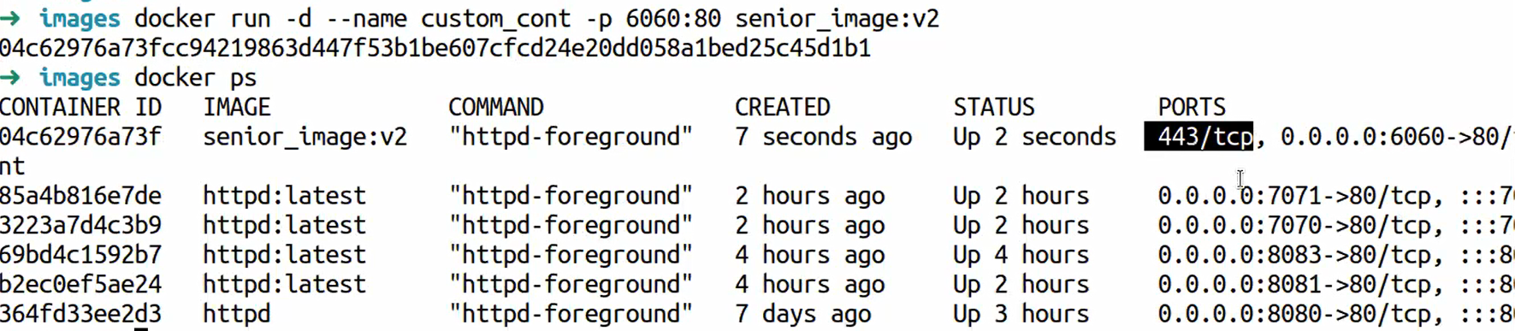

And I can map with external port



# **Docker Volume**

Storage outside the containers if the container destroyed the volume (data) still exists and accessible.

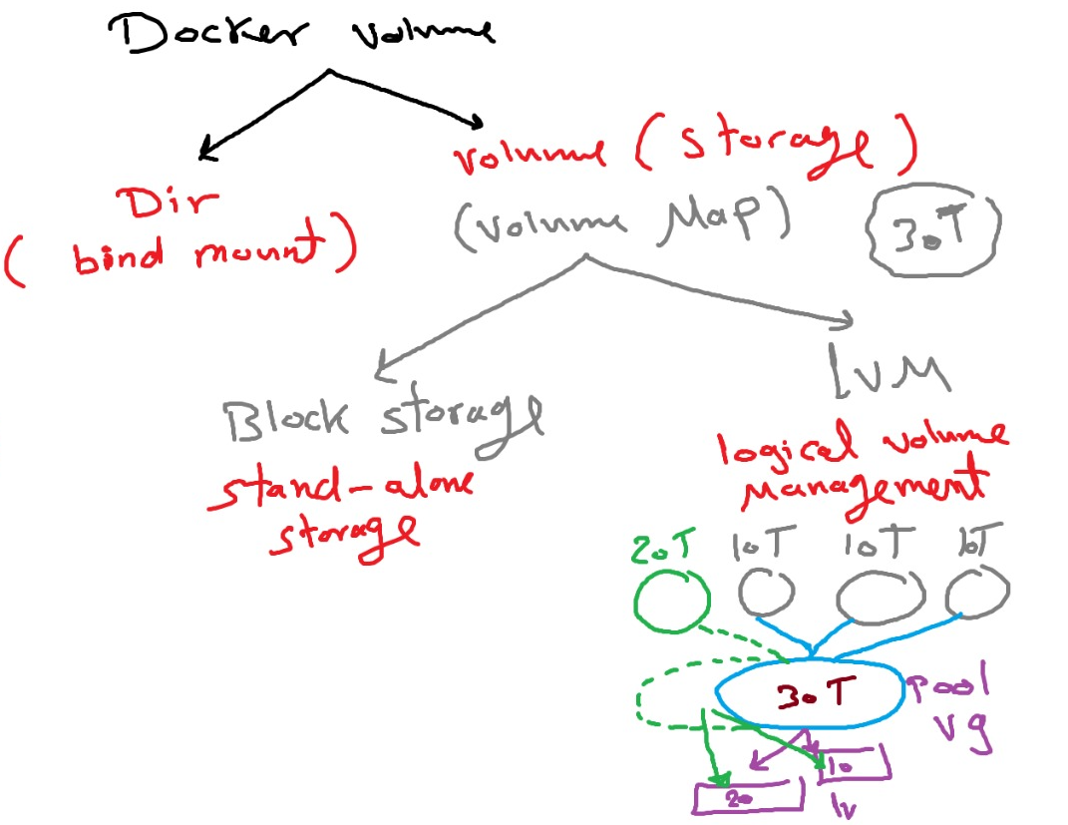

Dir(bind mount) :اديله فولدر و أقوله حط الفابلات هنا

Block storage : static hard disk if we need to increase the storage we need to change the hard with bigger one 🡪 so it ll be down time كل هارد لوحده لو عايزه ازود هنقل كل حاجه على هارد جديد اكبراو بارتيشن

Lwm : logical volume management is a storage sw solution collect all available storage in one logical volume group (VG) and we can create any num of partitions () so we can extends the VG storage by add more logical volume (LV) and the total storage is depends on the total storage in the VG pool (claster)

1. Docker pull mysql
2. Docker pull wordpress

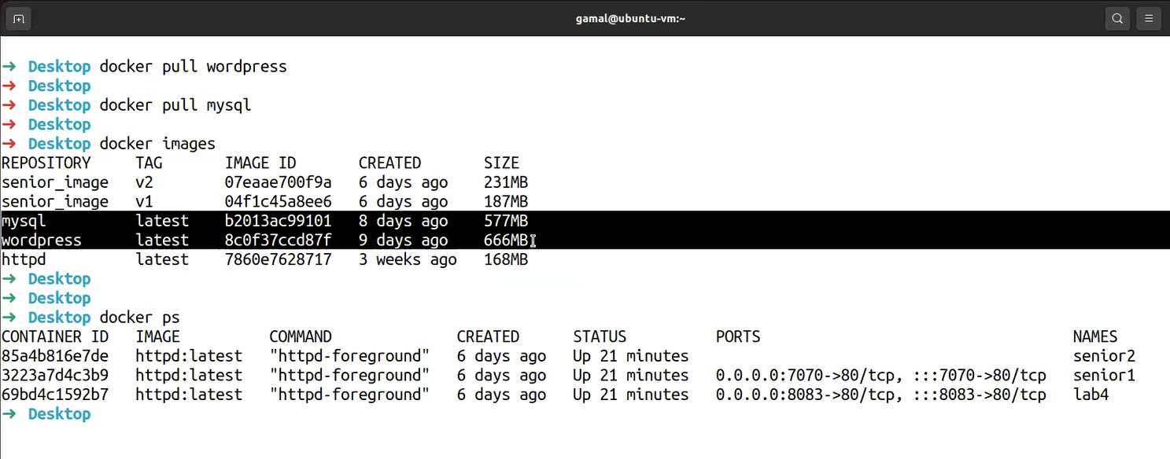

|  |  |
| --- | --- |
| Lsblk | List attached disks |
| Vm -> settings->disks-> add 🡪Sata(no restart neede) ->new virtual disk ->50 GB no allocate  Check 🡪lsblk look for disk you ll find 2 disks | Add disks to my machines |
| Fdisk dev/sdb  Pvcreate dev/sdb  Vgcreate dev/sdb  Lvcreate  Mkfs  mount | Merge haed disk to create VG pool |
|  |  |

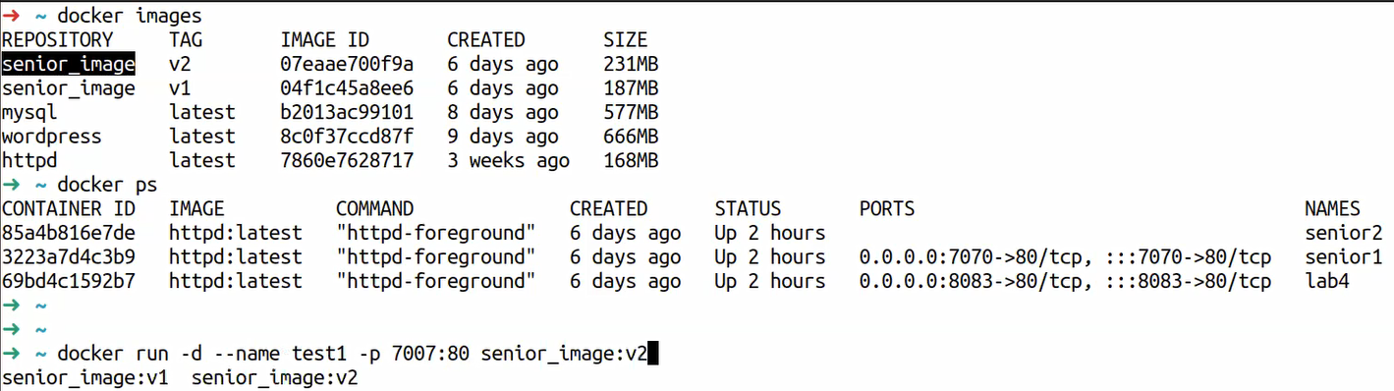

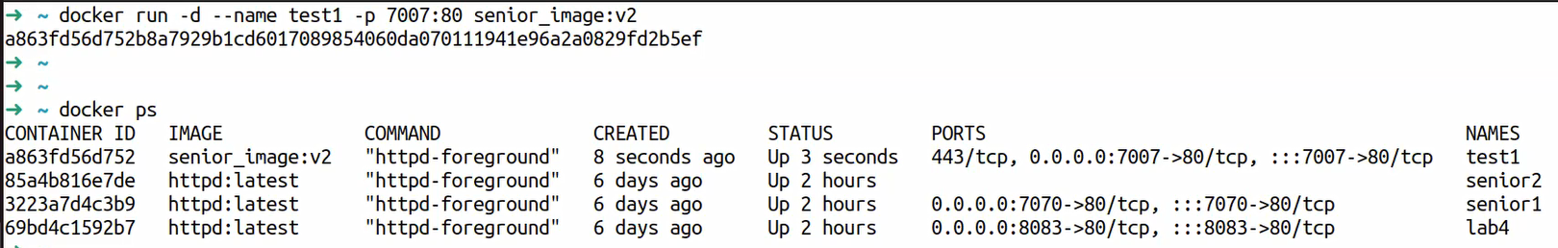

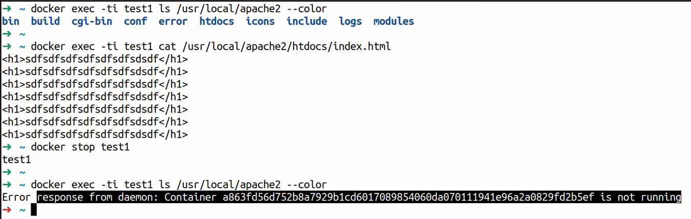

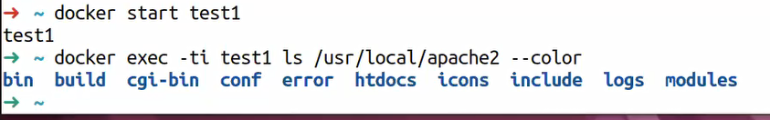

بيجيب كل المعلومات بتاعه الدوكر

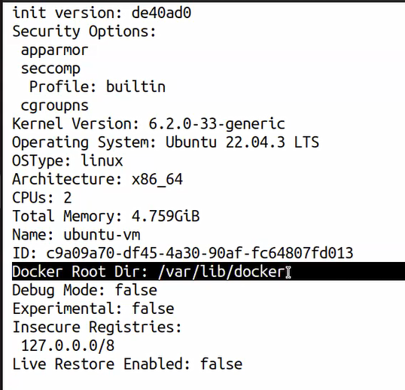

ده المكان الى الدوكر بيخزن فيه البيانات بتاعه الملفات بتاعته

لو دخلنا جواه هنلاقي كل المعلومات

-containers , volumes , …



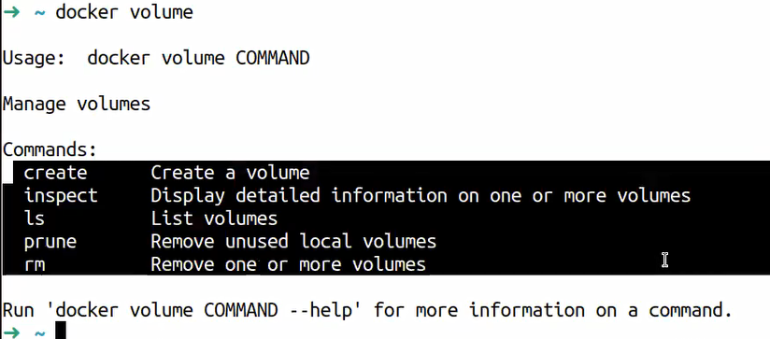

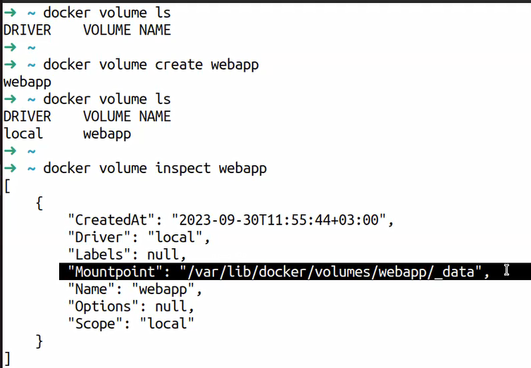

Mount point : ده المكان الى هفصل فيه الفايلات بره أي كونتينر و لو عاير استخدم الفايلات ده هلاقيها هنا

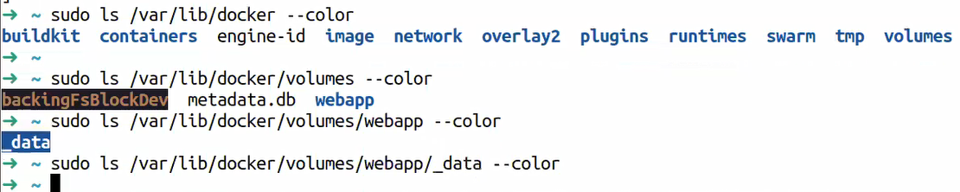

و عرفت مكانه و دخلت شفت انه فاضي Volume كده انا عملت

بتاعك اهه Volume الخطوه الجايه انى اروح اعمل كونتينر و أقوله ال

K8s الجديد لازم م الأول او لو عايز اغير يبقى هحتاج ال Volume لازم اعمل كونتينر جديد مينفعش كونتينر عندى و اديله ال

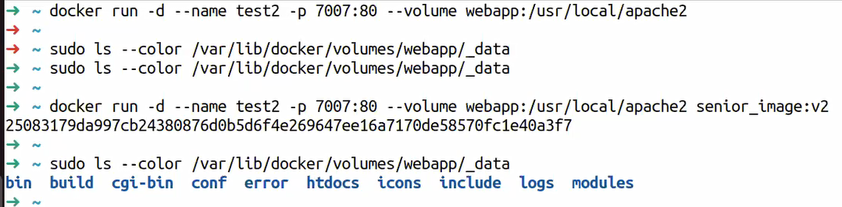

و التعديل الى هيتعمل هيسمع ف ال 2 كونتينر الى Volume و ممكن اعمل اكتر من كونتينر يبصو على نفس ال

هتفضل موجوده و ينفع اديها لاى كونتينر جديد Data عندى و لو اتمسحو خالص برده ال \

See full example in session 8 from min 1:16:30

# **Docker compose**

Separate docker tool used to run and manage multiple containers using yuml config file

Define service 🡪 define containers 🡪define network , volume ,img,port for each container

هدفها تقوم الكونتينرز بالترتيب الى انت عايزه

Start , stop,manage , more than one container using single cpnfig file

Docker compose لو عندك مايكروسيرفيس و عايزهم يشتغلو بترتيب معين و و يقفو بترتيب معين يبقى نستخدم

To get compose version 🡪Docker compose version

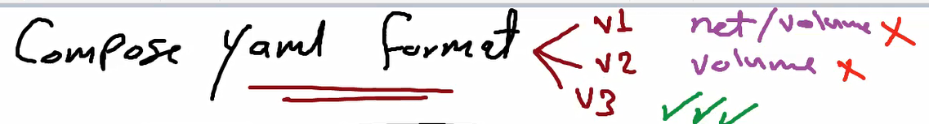

V1 : docker compose couldn’t be able to create network and volume (can use already existed network and volume)

V2: can create network and attach containers to this network , can’t create volume (can use already existing volume)

V3: all features available here

هنروح نعمل فايل و ده اسمه و الاسم ده ثابت زي الدوكر فايل

Volumesو ال Environmental variables بيبقي فيه كل ال



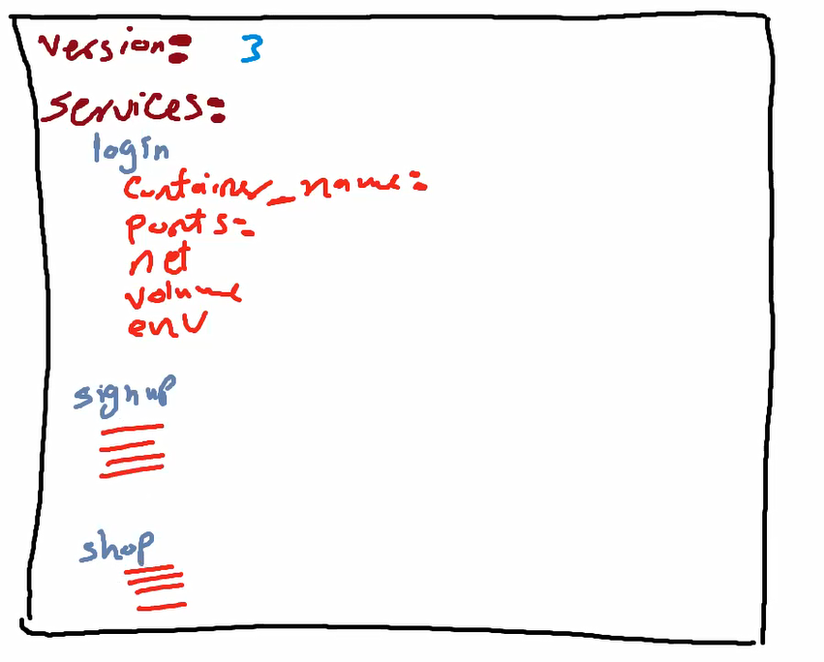

Ex: الأرقام يفضل يكونو بين ""

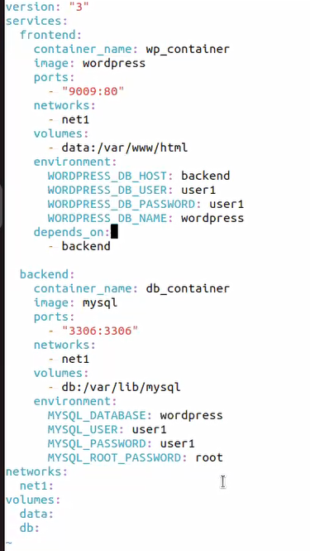

Networks : we use version 3 if I add networks section it ll be created if not exist

Not foundالى تحت و يعملهم من اول و جديد لو مش موجود تحت كمان يبقى Section لو موجود تمام ..لو مش موجود بينزل يبص على ال

Volumes و نفس الكلام ف ال

اقدر اعرفه من الدوكر هب /var/www/html حط جواه أي حاجه بتتحط ف الفايل Data اسمه Volume عندى

Depends on علشان احدد ايه الى يقوم قبل ايه هحتاج احط

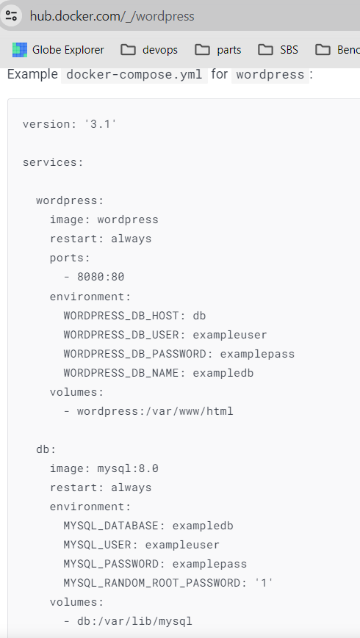

كتنبا الفايل و ده الى عندى دلوقتى

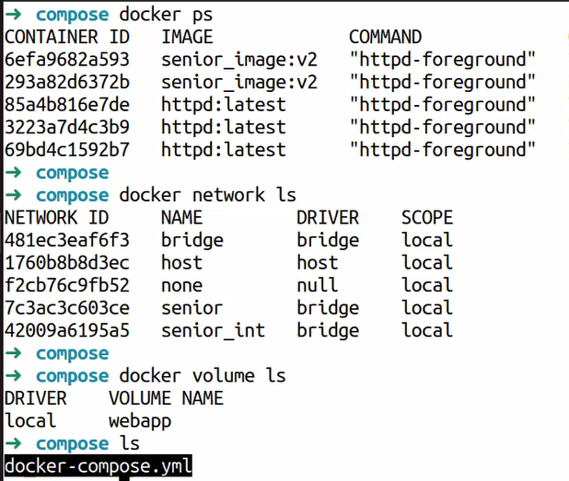

-f /path و لو احنا مش واقفين ف نفس مكان الفايل بنكتب Docker compose up -d نشغل الفايل بقى

Docker-compose.yml بيروح يدور على فايل اسمه

ثبCompiler بيشتغل زي

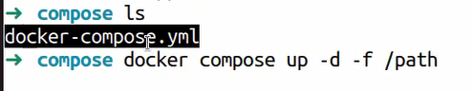

Note :Use zsh (enhanced shell)

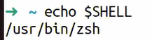

# vi /etc/nginx/sites-available/vproapp